Assignment 2

COMP 353

George Mavroeidis (40065356)

Due: Feb. 23 2020

**Question 1 (4.4.1):**

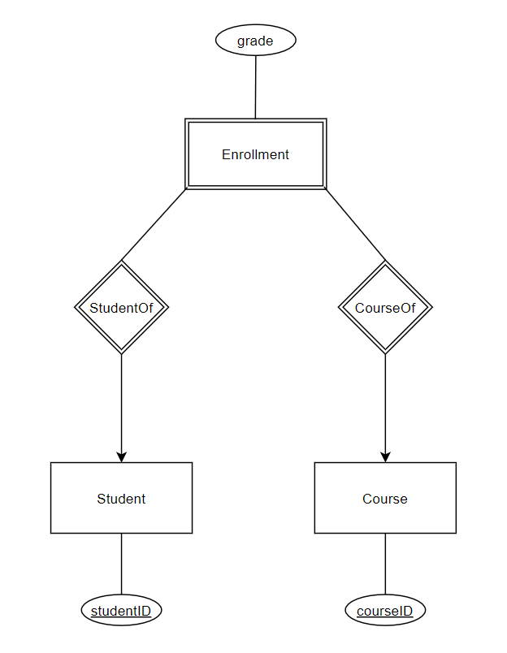

In this e/r diagram, the attributes of relations of each entity is displayed. Enrollment is a weak entity set and the two weak relationships indicate a many to one relationship from Enrollment to Student and Course. The grade is not part of the key for enrollments because it is an attribute that can be duplicated across many students that take a certain course.

**Conversion to relational data model:**

Employees(EID, SIN, EName, DoB, DID)

Department(DID, location, manager)

Supervisor(Supervisor.EID, Subordinate.EID) (differentiating between employee and supervisor)

WorksIn(EID, DID)

**Question 2 (4.5.4a):**

* Contracts(starName, studioName, movieTitle, movieYear, starAddress, studioAddress, movieGenre, movieLength);
* Stars(name, address)
* Studios(name, address)
* Movies(title, year, length, genre)

**Question 3:**

**E/R Model:**

* Person(name, address)
* Child(name, address)
* Father(name, address)
* Mother(name, address)
* ChildOf(childName, personName, childAddress, personAddress)
* FatherOf(childName, fatherName, childAddress, fatherAddress)
* MotherOf(childName, motherName, childAddress, motherAddress)
* Married(fatherName, motherName, fatherAddress, fatherAddress)

**Object-Oriented Method:**

* Person(name, address)
* Child(name, address)
* Father(name, address)
* Mother(name, address)
* FatherOf(childName, fatherName, childAddress, fatherAddress)
* MotherOf(childName, motherName, childAddress, motherAddress)
* Married(fatherName, motherName, fatherAddress, fatherAddress)

**Null Method:**

* Person(childName, fatherName, motherName, personName, childAddress, fatherAddress, motherAddress, personAddress)

**Question 4:**

**E/R Method:**

* H(g, h)
* G(a, c, e)
* E(a, c, b)
* F(c, d)
* S(g, c, a, f)

**Object-Oriented Approach:**

* H(g, h)
* G(a, c, e, b)
* F(c, d)
* S(g, c, a, f)

**Null Approach:**

* N(g, a, c, h, e, f, b, d)

**Question 5:**

1. **E/R Diagram:**

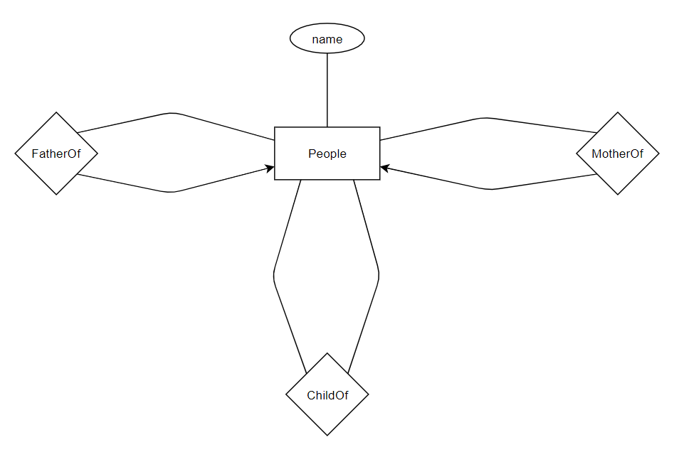

1. **E/R Style relational schema:**

* People(name)
* FatherOf(childName, fatherName)
* MotherOf(childName, motherName)
* ChildOf(personName, childName)
* MarriedOf(fatherName, motherName)

**Question 6:**

Added gender as an attribute to fit the tasked *isa* relationship

